1. Alampalli, Shravani
2. Team D – Phoenix
3. **Client**: Dr. Michael Oudshoorn
4. **Project** - Slack/Hipchat collaboration tool
5. **Role** – Issues Management.
6. **ITERATION PLAN:**

I have been assigned the role of issues management for this project. I am responsible for tracking all the issues in the project and ensures that they are resolved on time. I think 55% of work is completed by us. Until now project progress is on track and going well. We divided the requirements for Project management collaboration tool. And I’m working on task management.

**What accomplishments you made last week.**

We had two team meetings in order to get a detailed idea about the prototypes, use cases and test cases for all the requirements. And divided the tasks in another team meeting according to everyone’s strengths. Along with one of my team member, I’m working on task management. In these week, we finished prototypes, use case and test cases for task management. I’m also working on user manual doc and installation guide of final submission. In these week I worked for 45-48 hours. Pics for which I worked for.

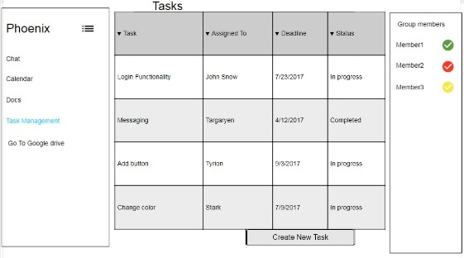 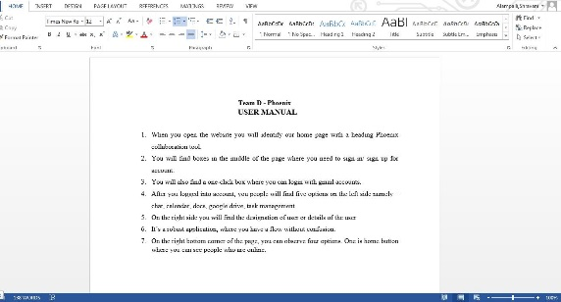

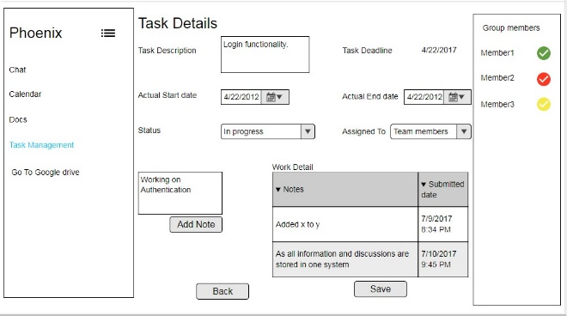 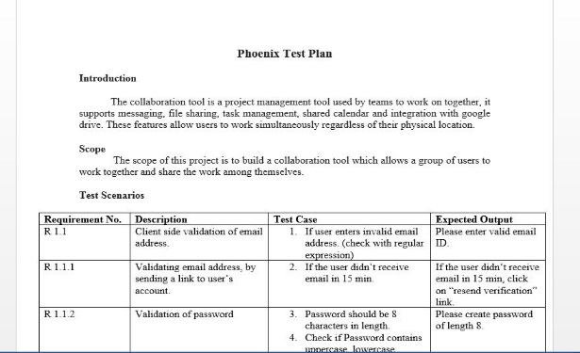

**Tasks to complete this week:**

1. Some more client meetings and get to know more about the requirements.
2. Team meetings in order to decide requirement documents and also to start and divide final doc.
3. I’m going to work on functional specification document for project management in these week. And also working on user manual and installation guide of final doc.
4. Make sure to push the documentation to Github repository.

**Any unresolved issues or blockers that keep you from making progress.**

No unresolved issues or blockers that effect my progress in these week.

1. **What is the riskiest component under development?**

Doing task detail prototype for the requirements is the riskiest component for up to now.

1. **What active efforts are most critical for client acceptance or GDP completion?**

Understanding the requirements of client and working on it to produce a required collaboration tool is very critical which is a final product. Satisfying client based on his requirements is also a critical thing.